The San Antonio and San Diego Mail Line

"The Jackass Mail"

by
Gerald T. Ahnert ©2019

“No factor of the pioneer days was more potent in the development of Arizona than the stage coach, rendering easily accessible a region hitherto reached only by the expenditure of much time, money, and a very great risk of life; replete in which heroism and fortitude and endurance were unexcelled in any other department of frontier life."
—Silas St. John

Jackass: A male ass.

Ass: Any of several hardy gregarious mammals (genus Equus) that are smaller than the horse, have long ears, and include one domesticated form (E. asinus) used as a beast of burden.

Mule: The offspring between a male ass and a mare.

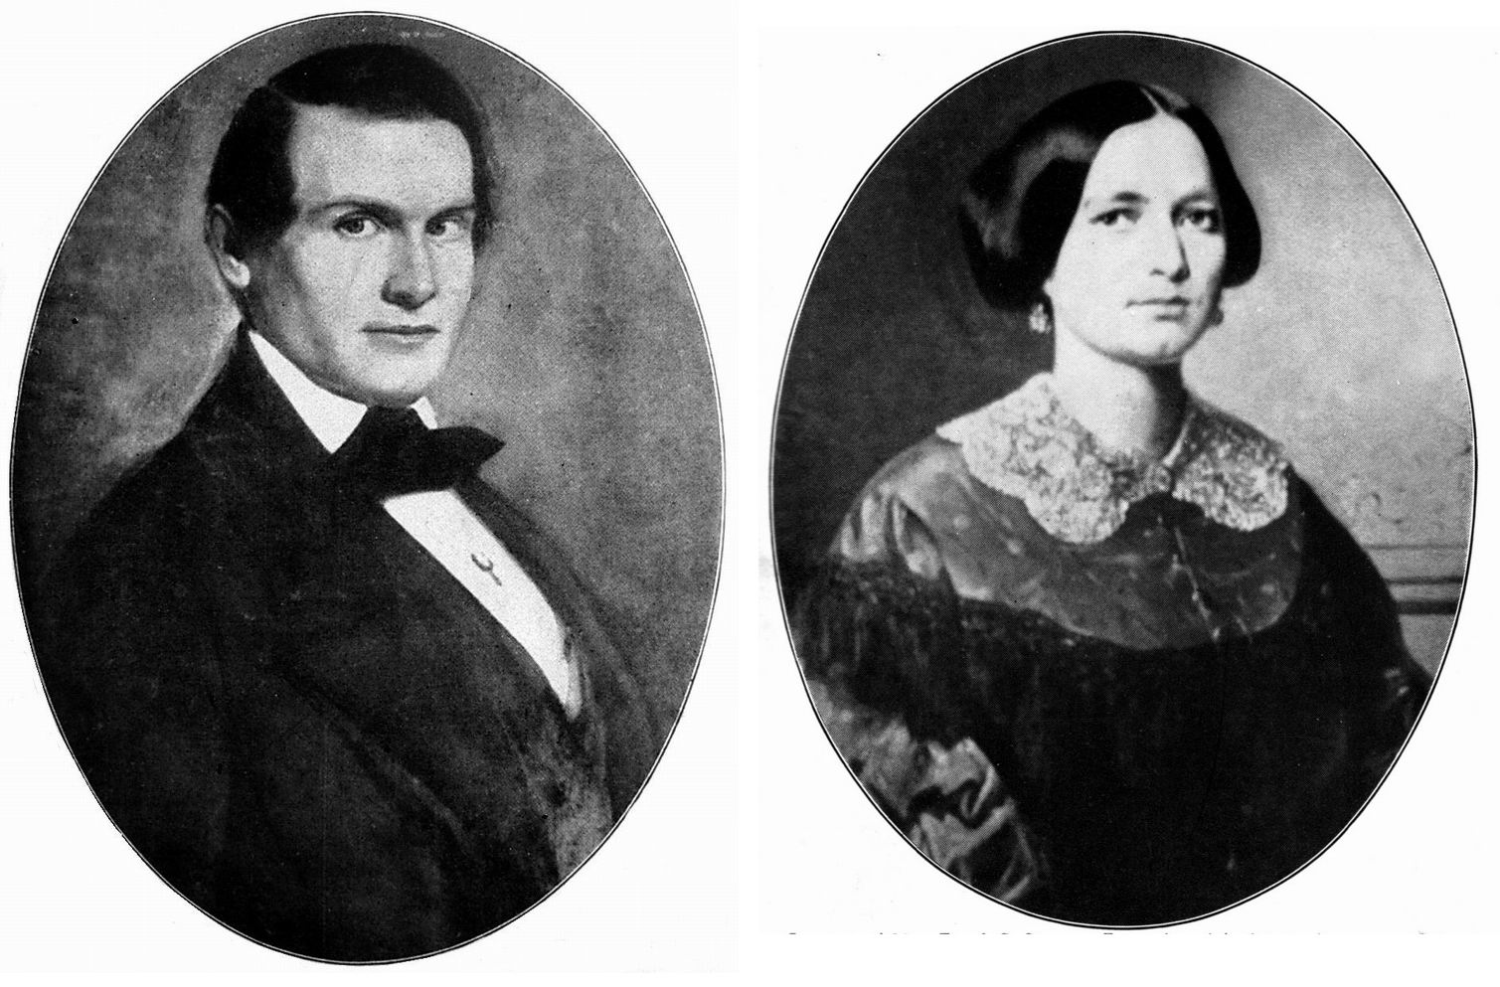
James E. Birch Julia A. B. (Chace) Birch
Owner of the San Antonio and San Diego Mail Line and his wife.

James E. Birch was born November 30, 1827, in South Carolina. In 1847, he moved to Providence, Rhode Island, where he worked in a livery stable and then went to work as a stage driver for Otis H. Kelton. Julia Ann Briggs Chace, of Swansea, Massachusetts, was the half-sister of Otis. James soon became engaged to her and they were married.
Birch went to Sacramento in 1849, because he saw the opportunity to make his fortune in the staging business and established his successful California Stage Company. His devotion to Julia was the reason for this venture:

"Birch's heart was already in Swansea Village when he arrived in Sacramento. He was engaged to Julia Chase [Chace], half-sister of his Providence employer, Otis H. Kelton. Birch historians, Mary McLennon Gallucci and Lieutenant Colonel Alfred D. Gallucci, wrote that Julia 'had told him of her wish to live in her native village of Swansea, Massachusetts, in a mansion filled with beautiful things, with servants to care for them, and he was determined to make it all come true for them by getting some of California's gold.'"

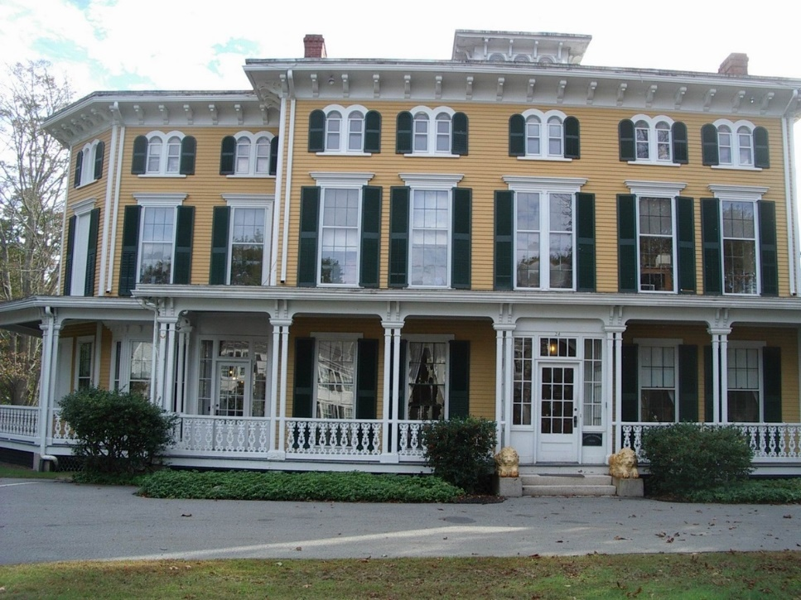
Photo: G. Ahnert 2017
The mansion in Swansea, Massachusetts, that James E.
Birch had built to suite the wishes of his wife Julia.

James E. Birch—President of the San Antonio and San Diego Mail Line

On July 1, 1857, the Post-Office Department awarded the first trans-continental mail contract No. 8076 to James E. Birch. The contract stated:

“…contract made with said Burch [Birch] from July 1, 1857, at $149,000 per annum, for semi-monthly service; to commence July 1, 1857, and expire June 30, 1861.
Leave San Antonio on the 9th and 24th of each month at 6 a. m.; arrive San Diego in 30 days.
Leave San Diego on the 9th and 24th of each month at 6 a. m.; arrive San Antonio in 30 days."

Although the purpose of the contract was to establish a land route for delivering mail to California, the long-term plan was also to put in place a more efficient trail for emigrants to help settle the west and also to act as a forerunner for the eventual building of a transcontinental railroad.
Isaiah C. Woods was chosen as Superintendent of the line. Woods had been an employee of Adams Express Co. in San Francisco. The company had financial difficulties during the banking crisis of 1854-'55. A large amount of money was unaccounted for and about that time Woods left for Australia. Although he was never charged with taking the money, the suspicion remained.

The Contract changes Ownership Before the Line Starts Service

Because of Birch's strong attachment to his wife Julia and their home in Swansea, Massachusetts, he left California on August 20, 1857, before the first successful delivery of the mail by the San Antonio and San Diego Mail Line. He wanted to be in Swansea to oversee the completion of the building for their mansion. On September 12, he was on the side-wheeler Central America (formerly the George Law) about 400 miles south of Cape Hatteras. In a violent storm the ship split her seams. Birch had refused the offer of a life-belt and a survivor relayed Birch's last words: "No, Gabe; it's no use," as he strode away, smoking a cigar whose glow he fully intended should be extinguished with the breath of his life.

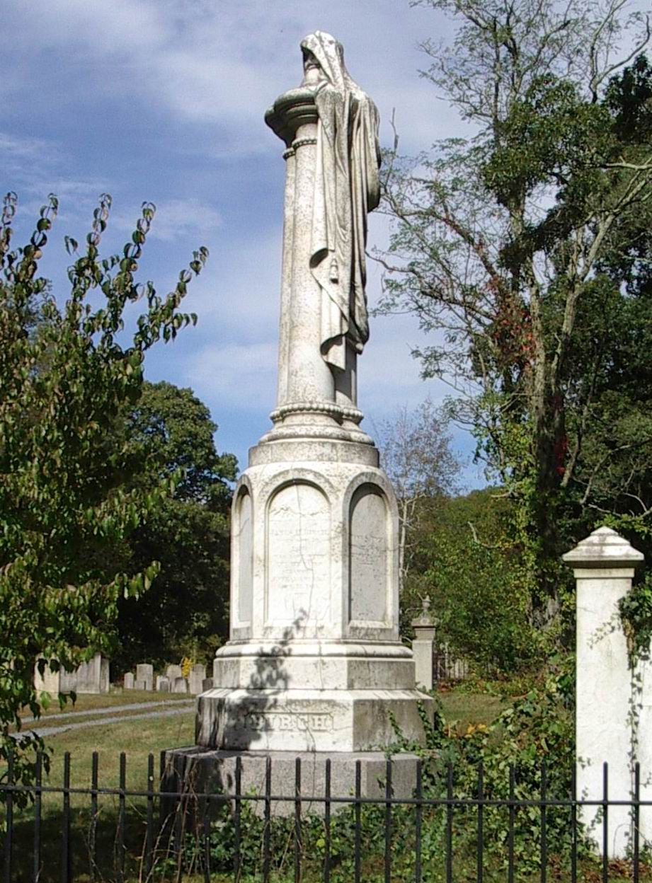
Photo: G. Ahnert 2017
James E. Birch memorial in Christ Church Cemetery, Swansea, Massachusetts:
"JAMES E. BIRCH, BORN NOV. 30, 1827, WAS LOST WITH THE ILL-FATED
STEAMER CENTRAL AMERICA, SEPT. 12, 1857."

As soon as his wife Julia received word of his death, she sold all interests in the line to her half-brother Otis H. Kelton. An ad was placed in San Antonio newspapers:

"San Antonio, November 20, 1857.
Whereas Julia A. B. Birch, of Swansea in the county of Bristol and Commonwealth of Massachusetts administratrix of the estate of James E. Birch, of the town and Commonwealth aforesaid has sold, assigned, transferred, conveyed, and set over unto Oltes [Otis] H. Kelton, of Charleston, South Carolina, for a good and sufficient consideration, all the stock of the mail lines and post routes from San Antonio, Texas, to San Diego, California, and from El Paso to Santa Fé, in Texas, so far as the said James E. Birch, deceased, has any interest in the same; and whereas the said Oltes [Otis] H. Kelton has appointed the undersigned his agent and attorney by power of attorney duly acknowledged, to take charge of and superintend his entire interest in said routes, as his sole agent: Now, this is to notify all whom it may concern, that all contracts and acts made by any person otherwise than those that I may appoint, touching the interest of said routes, will be treated as a nullity."

The Sacramento Daily Union reported the sale of the line. "W. Clifford" was the Birch family lawyer and "Kelton" was Otis H. Kelton, the half-brother of Birch's wife Julia:

"Overland Mail Contract. —The Washington correspondent of the Bulletin says:
I have learned from the Post Office Department that W. Clifford, of the Birch estate, has arrived here. Upon examination of the matters connected with the Birch Mail contract, he at once advised Kelton, the assignee, to relinquish the contract; and yesterday morning he did so—selling out, with the Postmaster General's approval and assent, to Giddings [George H.], who is now contractor, and who will no doubt fully answer the expectations of the Department and public. Mrs. Birch's friends rejoice that she has thus been saved from serious pecuniary disaster.
Kelton, as we learn, was not calculated to superintend the operations—and Giddings, who owned the principal portion of the stock on the eastern end of the route, had no confidence in his management, and would have retired from the affair altogether."

Before Birch's departure from his home in Swansea, Massachusetts, for California, he left orders with his wife Julia to order stage wagons from J. S. & E. A. Abbot to be used by the San Antonio and San Diego Mail Line. The stages were delivered, but with the selling off of the Birch estate, five of the stages found their way to Memphis, Tennessee, as shown in an ad for their sale:

“NOTICE—Contractors and Others Interested in Running Public Conveyances, FOR SALE FIVE PASSENGER CALIFORNIA WAGONS, built by J. S. & E. A. Abbott [Abbot]. Concord, N. H., expressly for the Overland Mail Route, (late J. E. Birch, Contractor,) completely furnished for mail and passenger service, entirely new, with extra whiffletrees, brace screws, lead bars, transom bolts, monkey wrenches, &c.
With the five above wagons are five sets of Harness for each five kegs of Wheel Grease, five boxes Crach Candles, Whipstocks and Lashes.”

After the selling of the Birch company assets, the line was sold to George H. Giddings who partnered with R. E. Doyle:

"On the 9th day of March, 1858, Postmaster General Brown entered into a contract with George H. Giddings, of Texas, for the transportation of the entire mail from San Antonio, by named intermediate points, to San Diego, in California, and back, twice a month, 'using therefore such means as shall be necessary to transport the whole of said mail, what every may be its size and weight,' for a compensation of $149,800, for a term of years to end 30th June, 1861….the contract with him, to take effect from the 1st of January, 1858."

The following restriction was the basis for amending the contract:

"This provision is inserted in the contract with Giddings, in writing, that it is made so with the express understanding that, if any other 'route should be put under contract that shall cover this in whole or in part, the Postmaster General reserves the power to curtail or discontinue the service on this route at his discretion. In addition to this written reservation, the body of the contract contains a written formula, which by a regulation of the department is inserted in all contracts, by which it is made a stipulation that the Postmaster General may discontinue or curtail the service 'whenever the public interests require such discontinuance or curtailment for any other cause, he allowing one month's extra pay on the amount of service dispensed with;"

Birch had been given less than a month to stock the line, but the time was too short to construct stage stations and improve the route of the trail. The line zigzagged from waterhole-to-waterhole following the Emigrant Trail. The line was unique in its accomplishment. It was the method used to supply fresh teams for the stages, instead of building stage stations containing livestock, that stands out as the genius of the organizers of this colorful line. The establishment of the line and its shortcomings was summed up by this passage:

"Yet the purpose of its earliest manifestation was, and must remain a mystery. The San Antonio & San Diego Mail, popularly known as 'The Jackass Mail,' may as well have been routed over the poles of the moon for all the good, in itself, it was ever to do toward solving the problem. As a means of communication between Eastern and Western civilization it was practically useless. As an aid to emigration it led 'from no place through nothing to nowhere,' and found, therefore, very few emigrants to aid. Reports, for example, of ten thousand California-bound wagons trekking over the Central or Salt Lake route were accompanied by other reports of no wagons at all west of El Paso on the line of the unaccountable Jackass, Why, then, had it been conceived?"

Although the above statement was somewhat harsh, there were emigrants on the Southern Overland Trail. The number was fewer than on the Central Overland Trail. After the discovery of gold in California in 1848, this wagon trail was used by many emigrants heading to the gold fields. According to Colonel Corrasco of the Mexican Army, in 1849, 12,000 emigrants crossed the Colorado River at its junction with the Gila. Emigration on the Southern Overland Trail was heavy until 1853 and then steadily declined. In 1858, when John Butterfield's Overland Mail Company significantly improved the trail, the emigrant travel on the trail again increased.
Instead of building stage stations and providing water along the trail by digging wells, making Mexican style tanks (berms across washes), or digging-out springs to provide adequate water, the line operated using frontier knowhow. Only one crude station was constructed in Arizona at Maricopa Wells. With the exception of the first few trips, the requirements of the mail contract were met, but the method for carrying passengers wasn’t very inefficient and the reputation of the line suffered from the many complaints by passengers.
The line only carried through-mail from its start until January 1, 1859. Passengers were carried for the entire limit of the contract. When John Butterfield was assigned the Overland Mail Company Contract No. 12,578, to start September 15, 1858, there was a duplication of service on 900 miles of the Southern Overland Trail. Because of this duplication, the San Antonio and San Diego Mail Line contract was modified. The line’s mail service could continue from San Antonio to El Paso, Texas, and from Fort Yuma to San Diego, California.

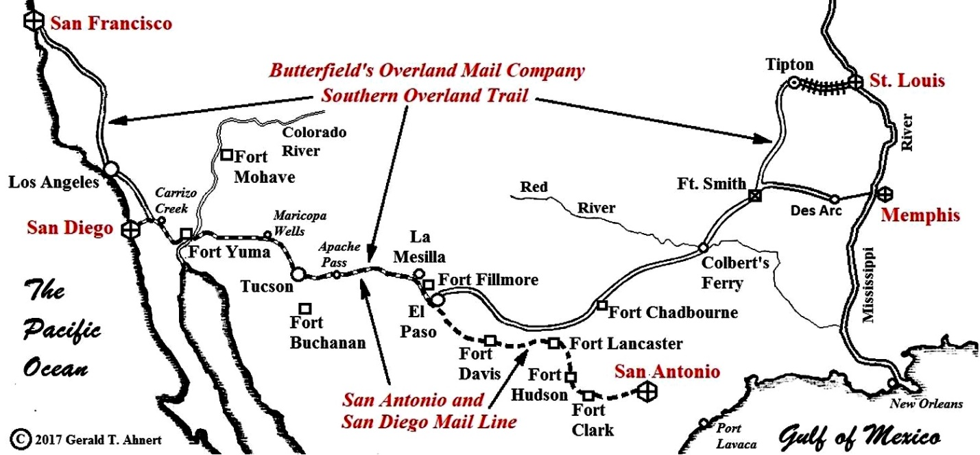
The 900-mile segment on the Southern Overland Trail where the San Antonio and San Diego Mail Line overlapped their service with John Butterfield's Overland Mail Company.
Map: ©2017 Gerald T. Ahnert.

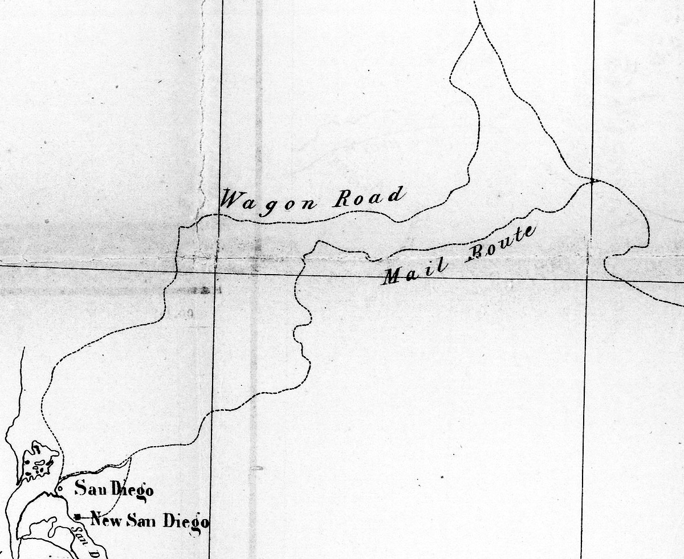
This section, from James B. Leach's Map No. 2, connects the Southern Overland Trail to San Diego. It is from information the Wagon Road Commission compiled in 1857-1858. The longer “Wagon Road” was for the passenger carrying wagons and the shorter “Mail Route” was for the mules carrying the mail.

The San Antonio and San Diego Mail Line Passenger Wagons

Little is known about the stages used by the San Antonio and San Diego Mail Line. Because the stage wagons ordered from J.S. & E.A. Abbot were sold after the death of James E. Birch, the only availability of stages were well used wagons that the line could find at forts and settlements along the trail. In November 1857, Superintendent Woods reported that the trail was stocked and tells of the wagons used for carrying passengers:

"The mail line had now nearly or quite two hundred head of mules west of the Rio Grande, stationed at San Diego, Carissa creek, Fort Yuma, Peterman's, Maricopa wells, Tucson, and La Mesilla. At each of these places agencies or stations had been established with abundant supplies or grain everywhere. We feed corn to all our working mules. I had made contracts for hay wherever the grass was likely to be short the coming winter. We had thirty-five mail carriers and agents along this part of the line; all well-armed border men, carefully selected for their familiarity with this kind of service. We had seven coaches on the road, and three more building in San Diego so that we could already take passengers through from ocean to ocean in stage coaches. I felt that I had carried out in spirit the agreement with your department to place a creditable service on the line, besides having complied with the letter of the contract in carrying the mail."

In 1859, George Foster Pierce boarded a San Antonio and San Diego Mail Line stage wagon heading west from San Antonio. He descibes the stage:

"The stage is not the old-fashioned coach of the East, but a kind of wagon, with an oblong body set on leather braces, having three seats, into which nine persons might crowd, but four or even six might find room enough. As we were but six in number, and one very small one, we had margin for change of position. The boot of the other stage was our store-room, containing cooking utensils and provisions. The captain gave the word of command, and away we went."

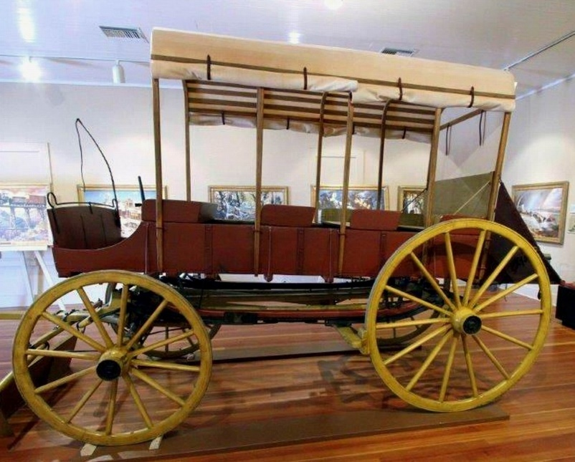
Phoecion R. Way wrote in his diary that the only reliable stage was an “ambulance” used from the Rio Grand to Tucson. Arizona’s Tubac Presidio State Park has on display a representation of Phocion's "ambulance." The replica couldn't have been made by anyone better than Hansen Wheel and Wagon Works. Their reputation for making Old West replica stages is renowned. Photo Courtesy: Tubac Presidio State Park.

From the many primary references, concerning the San Antonio and San Diego Mail Line passenger wagons, it is difficult to pinpoint any single style of that was used. They were called ambulances, carriages, wagons, waggons, and stages. The only definite style named in primary references is the word "ambulance" and this was usually the passenger wagon used between the crossing of the Rio Grande and Tucson.

The inconsistent mode of travel, often altering from mule back to passenger wagon, caused many passengers to complain. In June 1858, Phocion R. Way wrote the following in his diary:

"…3 o'clock P. M. We are now about 8 or 10 miles from Mesilla. We have stopped to feed. We took another passenger at Mesilla, which makes our whole number 5. We have also to carry feed for our mules, a large amount of baggage and the mail, which makes our load very heavy—unusually heavy. The driver is fearful that we will break down before we get through. The company should have sent another carriage but it was not done; in fact, the company have deceived us and acted shamefully from the start. They told us that the two carriages we started with would go all the way through to San Diego, and both of them have been taken from us. We left the last one at Fillmore and have an old wagon in its place. The one we have is strong and would do very well, but we should have another; it is not sufficient. The mules we have now are good, but those we have had were broken down things; and what is worse than all, they tell us now that the wagon will go no further than Tucson, and consequently those unfortunate fellows who are going through to San Diego will have to ride mule back from Tucson and keep up with the mail which is also packed on mules, and travels day and night. The poor fellows will have to travel 500 miles over a barren desert and I am afraid it is more than they can stand. It is a gross imposition that should not be born [sic] and the public should know it. They paid their money with the full understanding that they were to be taken through in an ambulance. The men employed along the line are fine fellows, and of course they are not responsible for this. This is an important route and will be much traveled, and [the] Government should see that it is properly managed."

After arriving at Tucson Phocion writes:

"The mail company do not run their stages farther than here, and those who paid their passage through must ride over a sandy waste on mule back and furnish the mules themselves, or stay here and get the fever and ague. This is a most rascally imposition and the company will very likely have to pay for it. If they are not compelled to pay damages, their business will be very much injured by the representations of those imposed upon. The mail company are certainly not consulting their own interests by acting this way."

Phocion tells of one of the line’s wagons:

"Arrived at Fort Fillmore at 4 o'clock in the afternoon. Here we will cross the Rio Grande and take a westerly course for Tucson. …We have our large ambulance drawn by 6 mules, and 4 passengers, 3 for Tucson and one for San Diego. …The ford is about 5 miles above Fort Fillmore. [Before Way reached Tucson, he calls this vehicle a "waggon" or "wagon" five times].

The line was 1,475 miles long and there were very few stations along the trail where spare stages could be stored. John Butterfield's Overland Mail Company had 100 stages located along the 2,700-mile trail. He had 175 stations about fifteen miles apart. A spare stage was distributed at a station approximately every thirty miles.

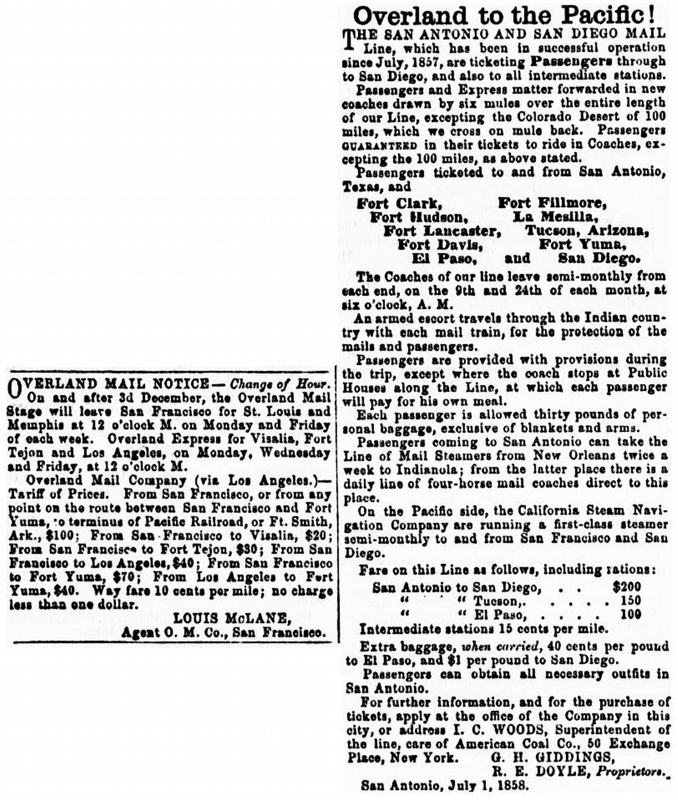

Ads for Butterfield's Overland Mail Company and the San Antonio and San Diego Mail Line Weekly Arizonian, Tubac, Arizona, from March to September 1859.

The San Antonio and San Diego Mail Line ad had been appearing in newspapers since July 1858. The two lines were competing for passengers on 900 miles of the Southern Overland Trail. San Antonio and San Diego Mail Line passenger Phocion R. Way reported that he traveled on broken-down passenger wagons and by mule back even though the ad stated: "Passengers GUARANTEED in their tickets to ride in Coaches, excepting the 100 miles as above stated." The 100 miles was given as the Colorado Desert.

Unreliability of Delivering the Mail by Stage Wagon

The passenger wagons could not always be relied on to meet the delivery time requirement, as they stopped many times along the trail to prepare meals and for periods of sleep, as well as the unreliability of using many different wagons of varying ages prone to breaking down. The mail was often transported separately on mule back, as it had to meet the thirty-day delivery requirement between San Antonio and San Diego.
Correspondent Charles F. Huning reported in March 1858, that after leaving San Diego they "…road on horseback that day…" before they arrived at Carrizo Creek. After arriving at Vallecito, Huning writes "Here we met the passengers coming from the other end of the route, five in number; they complained very much, and had had a very hard time of it…" When he arrived in Tucson he writes "We got to Tucson, was very much disappointed at hearing that I would have to stay at that place until the return of the stage from Mesilla." This was sometime before Christmas and later he writes "On New Year’s Eve, I was glad to see the coach arrive."
Another correspondent writes that while at Carrizo Creek "We waited here several days, until I. C. Woods [the line Superintendent] came up with about seventy mules, and another stage also, heavily laden."

Providing Mules was a Major Problem

In November 1857, a herd of stock was taken from Fort Yuma to Maricopa Wells for use upon the central section. Silas St. John was in charge and was assisted by James Laing of Kentucky and Wm. Cunningham of Iowa.

"…Early in December 1857, three coach loads of passengers, the first from California, bound East, 18 persons in all reached Maricopa. No attempt was made to put them through on mail time - extra teams were driven loose with the stage and as far as practicable two hours drives were made with an interval of two hours rest - thus fifty miles a day were made, but absence of water and feed were often disarranged the schedule. St. John put this party through to San Antonio, Texas, without an accident or especial incident."

Changing Mules without the aid of Stage Stations

Superintendent I. C. Woods gave this in his report:

"On my return trip from San Diego, I brought my mules into our Maricopa station in much better condition than when I left Fort Yuma with them. My practice was this: while one of my two teams of mules as working in the coaches for a couple of hours at a walk, I would have the other team under charge of an experienced man, either ahead or behind the coaches, eating their fill of grass, beans or what every they could find. At the end of two hours we would change teams, giving the other set of mules their chance for loitering behind to eat. …We keep a mulada at Fort Yuma for our changes, which we send out every day to feed in the river bottom, under charge of a Mexican herder, bringing them in at night for safety."

Correspondent Charles F. Huning wrote from Fort Yuma: "We started again next morning—change of coach and animals. Six mules were hitched on, and as many more for relays; there were three drivers, one for the coach, one side driver, and another for the loose mules."

Meals along the Trail

A company ad in an Arizona newspaper published in mid-1859 gave this for supplying meals along the trail: "Passengers are provided with provisions during the trip, except where the coach stops at Public Houses along the Line, at which each passenger will pay for his own meal."
Phocion R. Way writes that meals were taken along the trail and prepared by a Mexican cook: "At dinner today [at Cow Springs in New Mexico] our Mexican cook gathered some wild sage plant and made some tea which some of the party liked very well, but I did not; the sage taste was too strong." Near Dragoon Springs: "…our captain shot at an antelope as we came along, but he did not hit it. It was too far off. We were all very anxious that he should hit it for we have had no fresh meat for 2 days." Arriving in Tucson he writes:

"There was no fresh meat to be had and we have been in a bad fix if the mail party had not kindly invited us to eat with them. Even they could procure nothing and were compelled to live on the remains of the provisions they had on the road, a little bacon and coffee and bread so hard from age that you could not bite it. They have to do their own cooking and all travelers must do the same or hire a Mexican to do it for them. Our fare, as bad as it is, is better than the average in this town. We spread our old greasy cloth on the ground in the corral. Some of the hungry citizens watched us while we were at our meals, and when we were through, they eagerly devoured the scraps. I have just learned that our captain has succeeded in buying a roast of beef. If this proves true, won't we have a feast today?"
Sleeping along the Trail

In a report by Superintendent I. C. Woods was: "When camping, after a drive of about ten miles, we unharness in the middle of the road, and from one end to the other, from San Antonio to San Diego, the road can almost be measured by the ashes of our camp fires."
Phocian R. Way gives a number of accounts about sleeping along the trail. On January 11, 1858, he wrote: "Camped last night about 10 miles this side of San Pedro [River]. Hobbled our mules, stationed our guard, and retired to rest on the ground as usual." This description very closely describes the scene of sleeping along the trail drawn by William H. Hilton.
After arriving in Tucson Phocion gives this colorful account:

"There is no tavern or other accommodation here for travelers, and I [was] obliged to roll myself in my blanket and sleep either in the street or corral, as the station house had no windows or floor and was too close and warm. The corral is where they keep the horses and mules, but I slept very comfortably as the ground was made soft by manure."

Charles F. Huning reported that on reaching Lassiter's in California: "We had to sleep in a low hut with a fire in the middle, regular Indian fashion, having to lay down to sleep to keep out of the smoke; . . ." After reaching their next station: "We arrived at our stopping place, (rode on horseback that day,) slept in a house on a hard dirt floor." In the Ninety Mile Desert; "We stopped at Indian Wells all night, and found enough water for ourselves and animals; also, some wood to make a fire—the night was pretty cold." Arriving in Tucson: "Beds are a thing scarcely known in this country, and we had to sleep on the floor the whole time."

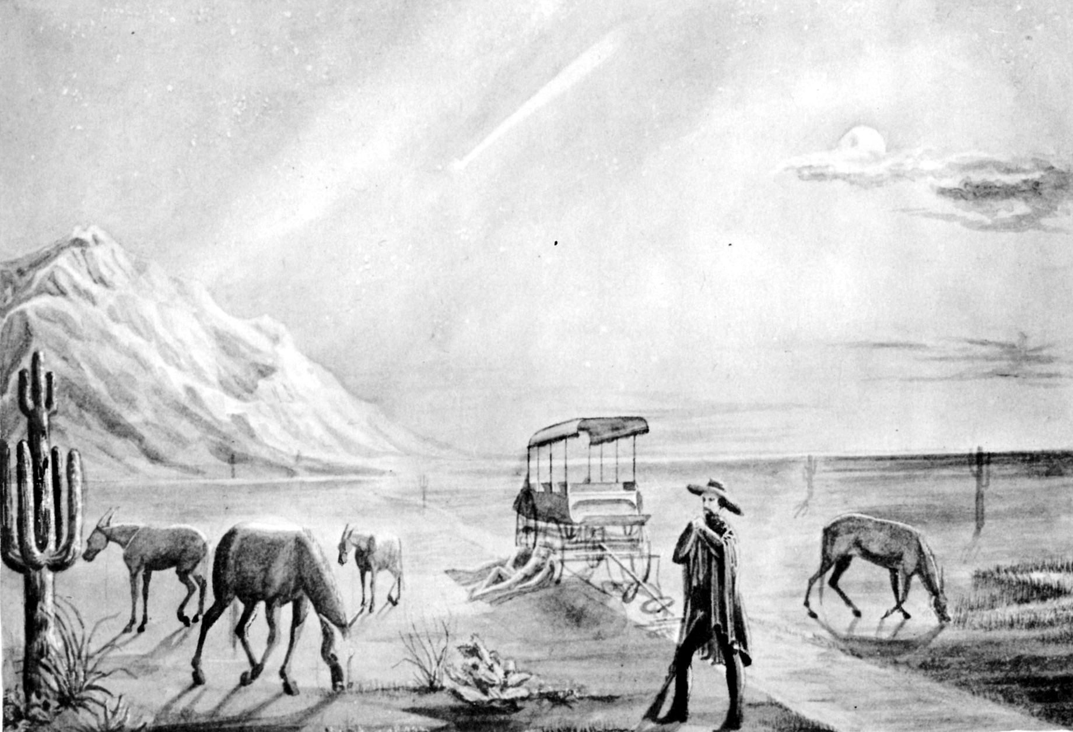
Drawn by William H. Hilton. Courtesy Huntington Library
Hilton was traveling through Arizona on a Butterfield stage wagon, October 3-5, when he came across San Antonio and San Diego Mail Line passengers sleeping along the trail. Phocion R. Way wrote: "Camped last night about 10 miles this side of San Pedro [River]. Hobbled our mules, stationed our guard, and retired to rest on the ground as usual."

The original Hilton drawings are in the Huntington Library collection, but he left no description for his drawins. In a conversation with Huntington Library Archivist Alan Jutzi, it was determined that Hilton may have made his drawings from memory sometime after his trip. The stage wagon shown gives few details to determine the classification of the stage. His drawings of Butterfield stage wagons along the trail, which show little detail, also look similar to the passenger wagon in this drawing.

Indian Attacks

"ATTACK BY INDIANS UPON THE SAN DIEGO MAIL. "

In the San Antonio Herald of the [August] 5th inst. [1857], we find the following:

The San Antonio and San Diego mail train, under charge of Capt. Wallace [Big Foot], was attacked by a party of about 100 Apaches on the 25th of July last near the upper crossing of Devil's river. The mail party consisted of Capt. Wallace and five men, one six mule coach and twenty-two head of horses. One of the mail boys was killed. Wallace was himself wounded. W. Clifford, of New Orleans, was killed. The mail party fought them for about two hours but the Indians were too numerous; they took all the mules, coach, saddles, and in fact all that the mail party had. Only five of the men escaped with their lives, and came back on foot to where a company of soldiers were camped, within about sixteen miles of the scene of action.
This is sad news; but we learn from Mr. George Giddings, of this place, who is interested in the contract, that it will not deter them from going ahead with the mail. The first mail is supposed to have gotton (sic) on safely. We learn that Mr. Geo. Giddings will accompany the next party on the 9th inst. in person, as far as El Paso."

The line continued to have problems with Indians stealing the line's mules:

"We learn that Indians are still committing depredations in the vicinity of Fort Davis [Texas]. On the 2nd of this month [June 1858], they stole twenty-nine mules, belonging to the San Diego Mail Line Company, from a place close to the Fort."

In a newspaper article titled "Southern Account of the Battle at Fort Fillmore" it tells of an attack on the San Antonio to San Diego Mail Line. It is from a letter received from the agent of the S. A. and S. D. Mail Line at El Paso, Texas, dated July 29, 1861, "Our mail to Tucson was cleaned out by Apaches, and hands killed. Thomas' party, seven in number, nine mules killed, and the coach entirely destroyed. It occurred at Cook's springs."

The First Mail from San Antonio

The Texas Almanac for 1858 told of the first mail run from San Antonio, but there are many inaccuracies in their article. An account in the Sacramento Daily Union gives us an accurate account of the first trip:

"We take great pleasure in announcing to our readers in the upper country that the Overland Mail which left San Antonio, Texas, on the 9th and 24th of July, under the contract entered into between the Government and James E. Birch, of Sacramento, arrived on the 31sr ult., at noon precisely, in charge of James E. Mason—the party of the 24th having made the trip in the unprecedentedly short time of 34 traveling days, the entire trip occupying 38 days.
…Mr. Mason left San Antonio on the morning of the 9th of July, in company with four men. The time afforded for preparation was exceedingly short, so that no relays of mules could be sent ahead, and even the animals ridden by the party had to be picked up as they could be found, at an hour's notice. Of course, this caused a material delay, which was unfortunately still further augmented by the sickness of the conductor. At El Paso, however, they took an ambulance, and had proceeded as far as Cienega De Sauz [San Simon River], when they were overtaken by the party that left San Antonio with the mail on the 24th, in charge of Captain James Skillman, who had come in an ambulance the entire distance from San Antonio, without encountering any difficulty on the road. The Pimo Villages, where Mr. Mason took both mails and with one companion, pushed on with pack mules, making the trip to San Diego in the unequalled time of nine days, across the worst part of the entire route, including the Colorado desert.
…Mr. Mason's party saw no Indians after they left El Paso, and but few before that. Capt. Skillman, however, informed him that subsequent to his departure, a party of Lipans and Mescalores attacked a party of six men who were proceeding to Fort Clark, with twenty-four mules for relays, between the two crossings of San Pedro or Devil's River, in Texas, and killed one man, wounded another, and possessed themselves of the entire band of animals, one of which, however, was subsequently recovered. Had these mules reached Fort Clark safely, so that they could have made the trip to El Paso in ten days, which would have brought the mail to San Diego in thirty days.
…The immigration across the Southern route, at present, is reported by the mail riders to be quite large, upwards of one hundred wagons having been passed, with considerable quantities of stock. As the mail riders, however traveled mostly in the night, they had not much opportunity to elicit information from the immigrants. A party of six, however, has been attacked at Puerto Del Dado [Apache Pass, Arizona], by the Apaches, who killed two men and stole sixteen yoke of cattle. The immigrants mostly intend settling in the northern section of our State, although their first resting places will be in Los Angeles and San Bernardino counties.
…As was the case with the first trains from this side, the way mail far exceeded the through mail, but there can be but little doubt that as soon as the establishment of the route is generally known, a great portion of the correspondence of California and the southern and southeastern States will pass over the San Antonio and San Diego Line.
…The mail party which left San Diego on the 9th ult., and which it will be remembered was detained by very much the same accident which delayed the first train from San Antonio, was met near Indian Wells, on the Colorado desert, in good spirits, and making good time.
The Wagon Road Commission, with Mr. Leach at its head, were expected daily at San Antonio, when the mail of the 24th left—the party having been detained at Memphis, waiting for the Paymaster. Mr. Leach had one hundred and forty men engaged, with eighty wagons, and would increase his complement of men to four hundred in Texas and the territory adjoining." Little "through" mail was delivered in the early months and mostly "way" mail was carried.

The First Mail from San Diego

According to Mr. Mason the first mail left San Diego on July 9, 1857. According to Silas St. John in the following, the first mail left San Diego in October 1857. He is probably mistaken as he states that he was accompanied by Charles Mason. James E. Mason was with the first mail delivery from San Antonio and arrived at San Diego August 31, 1857. Charles Mason and James E. Mason are probably the same person. Silas St. John was correct that he carried the mail from Warner's Ranch to Fort Yuma with Mason in October 1857, but it wasn't the first mail to leave San Diego. St. John mentions Big Foot Wallace in the October delivery. Wallace was wounded in the July 25 attack, but had apparently recovered for the October delivery. A confirmation that St. John was on the October 1857 delivery starting from San Diego is an article in the Sacramento Daily Union, November 14, 1857, in which he states he is "en route to San Antonio, Texas, with the overland mail."

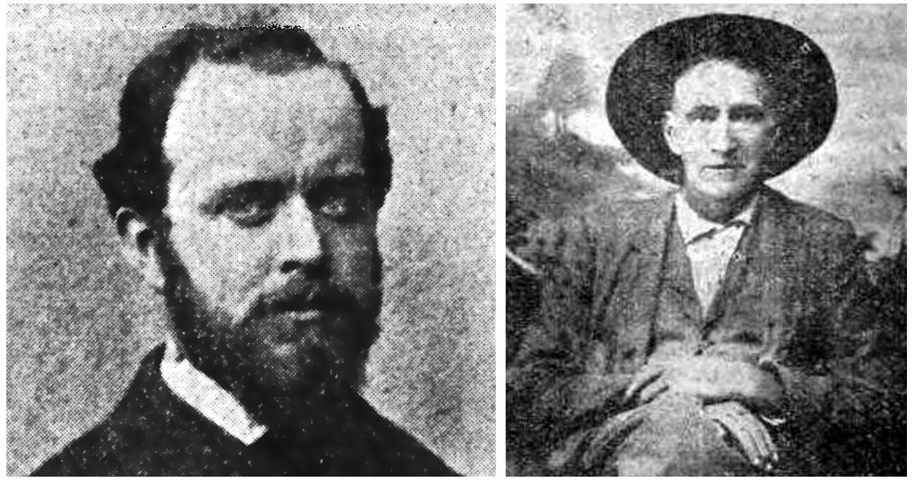
Silas St. John William A. A. (Bigfoot) Wallace
Silas St. John and Bigfoot Wallace often carried the mail on mule-back from San Diego to Fort Yuma, California. Silas later worked for Butterfield’s Overland Mail Company when he lost his left arm as the result of an attack while he was helping to build Butterfield’s Dragoon Springs Stage Station in Arizona. His photo was taken in 1859 when he returned for a short visit to his hometown of New York City.

The following is St. John's account from a personal manuscript:

"…The first mail east bound was started from San. Diego, Cal., in October 1857. Although the advertisement in the San Francisco papers noted four horse Concord coaches, it was really carried in saddle bags until some months later when stations were established and stock strung along the line.
Charley Youmans was the first rider - leaving San Diego at 12 midday sharp, amid booming of one canon and fusillade of guns and pistols. He had two remounts, reached Cariso [Carrizo] Creek via Warner's ranch at 8 P. M. Here the mail was taken to the next station by Silas St. John - accompanied by Charles Mason to the next station, Jaeger's ferry at Ft. Yuma, in 32 hours, without a remount. Fairly good time for 110 miles, only one water hole open, Cooks Well, at the time.
From Yuma, Capt. Wallace (Big Foot) rode to the next station - Maricopa Wells. He had a companion and two relief horses. From Maricopa Wells to Tucson, John Capron and Jim McCoy were the riders - the initial trip.
A herd of stock was taken during November, 1857, from Yuma to Maricopa Wells for use upon the central section, Silas St. John in charge assisted by James Laing of Kentucky and Wm. Cunningham of Iowa."

The San Antonio and San Diego Mail Line thanks
John Butterfield for Improving the Trail

In September 1858, the San Antonio and San Diego Mail Line and emigrant travel on the trail benefited from John Butterfield’s Overland Mail Company significantly improving the trail, by constructing many stage stations with water sources averaging fifteen miles apart. The San Antonio and San Diego Mail Line was operating on 900-miles of the improved trail. In October 1859, Superintendent Isaiah C. Woods complimented Butterfield for these improvements and the benefit to the San Antonio and San Diego Mail Line:

"The San Diego Overland Route—Interesting News—From I. C. Woods, who has just crossed the continent on the San Diego and San Antonio Line, says the San Diego Herald, we gather some items which may be of interest:
Woods pays a high compliment to the staging of the Butterfield Overland Company, along the Gila and over the Desert, particularly to Superintendent Buckley and Warren Hall, the Road Agent of this division. They have, he says, really worked wonders in organizing their road in a manner which would be a model in any country.
The immigrants are coming slowly along, feeling in no hurry to enter California much before the rains have brought on the new grass. The stations of the Overland Mail companies and the wells dug by these enterprising men, are proving of incalculable benefit to those crossing with their own teams. The immigration on the Southern route, this year, will figure up from ten thousand to fifteen thousand souls, with a very large amount of cattle and sheep. The old complaints of the immigrants are at present unheard of, owing to the better knowledge of the country now so readily obtained.”

In June 1860 Butterfield passenger Wallace reported to the Daily Alta California the following:

"Between Vallecito and Algodones there are eight of these stations, varying from nine to sixteen miles apart. Wells have been sunk at each station, and abundance of good water is obtained, except at the Monument and Garden stations. These waters are brackish and bitter—a flavor not delicate to the taste. Drinking-water is carried from the other stations.
These stations are of incalculable worth to emigrants, who are no longer forced to depend upon the precious supply of water which the wells, afforded, and which were liable to be covered up by the sand-waves that move over the desert."

Notes

Executive Documents printed by order of The House of Representatives during the First Session of the Thirty-Fifth Congress, 1857-1858, Washington, 1858, p. 430.
Silas St. John, The Establishment of the Trans-continental Mail Service upon the Overland Stage Route, Sharlot Hall Museum, Prescott, Arizona, p. 1. Note: Silas St. John worked for both The San Antonio and San Diego Mail Line and John Butterfield's Overland Mail Company.
Portraits in Birch-Stevens Mansion, Swansea, Massachusetts.
Barbara M. Ashton, No Place to Go, Stevens-Children's Home, Inc., Swansea, Massachusetts, 1997, p. 100.
Mary McLennon Gallucci, James E. Birch, Sacramento Historical Society, Sacramento, California, 1959, p. 3.
Daily Alta California, August 13, 1855, "Departure of Isaiah C. Woods for Australia, in the ship Audubon."
Wayne R. Austerman, Sharps Rifles and Spanish Mules, The San Antonio-El Paso Mail, 1851-1881, Texas A & M University Press, College Station, Texas, 1985, p. 105.
Ibid, Banning, Six Horses p. 97.
J. [I.] C. Wood, Superintendent, REPORT TO HON. A. V. BROWN, POSTMASTER GENERAL, ON THE OPENING AND PRESENT CONDITION OF THE UNITED STATES OVERLAND MAIL ROUTE BETWEEN SAN ANTONIO, TEXAS, AND SAN DIEGO, CALIFORNIA, Washington, D. C., March—, 1858, p. 27.
Sacramento Daily Union, California, April 3, 1858.
Memphis Daily Appeal, Tennessee, June 25, 1858.
Index to the Miscellaneous Documents of the Senate of the United States for the Second Session of the Thirty-Sixth Congress also of the Special Session, Misc. Doc. No. 15, "The Committee on Post Office and Post Roads, to whom was referred the memorial of George H. Giddings, of Texas, having considered the same, submit the following REPORT," p. 1.
Captain William Banning and George Hugh Banning, Six Horses, The Century Co., New York, London, 1930, p. 108.
Benjamin Butler Harris, The Texas Argonauts and the California Gold Rush, "The Gila Trail," University of Oklahoma Press, Norman, 1984, p. X.
Gerald T. Ahnert, True West Magazine, September 2019, “Surviving the Ride on the Jackass Mail,” pp. 42-45. Note: This article tells of the many problems for meeting the schedule and what it was like traveling on the line.
Index to the Miscellaneous Documents of the Senate of the United States for the Second Session of the Thirty-Sixth Congress also of the Special Session, Misc. Doc. No. 15, "The Committee on Post Office and Post Roads, to whom was referred the memorial of George H. Giddings, of Texas, having considered the same, submit the following REPORT," pp. 2-3.
James B Leach, The Executive Documents, Second Session, Thirty-Fifty Congress, 1858-'59 "REPORT UPON THE PACIFIC WAGON ROADS, CONSUTRUCTED Under the direction of the Hon. Jacob Thompson, Secretary of the Interior, in 1857-'58-'59, El Paso to Yuma Wagon Road." (Includes two maps).
Ibid, Woods, REPORT TO HON. A. V. BROWN, POSTMASTER GENERAL, p. 27. Note: Bold for author's emphasis.
George G. Smith, THE LIFE AND TIMES OF GEORGE FOSTER PIERCE, D. D. LL. D, Hancock Publishing Company, Sparta, GA, 1888, p. 382.
Phocion R. Way, Overland Via "Jackass Mail" The Diary of Phocion R. Way, Overland Via "Jackass Mail,” Part Two, Arizona and the West, Vol. 2, No. 2, December 1960, p. 159.
Ibid, Phocion R. Way, p. 151.
Waterman L. Ormsby, The Butterfield Overland Mail, The Huntington Library, San Marino, California, 1991, p. 139.
Sacramento Daily Union, March 12, 1858.
Sacramento Daily Union, January 11, 1858.
Note: Silas St. John, James Laing, and William Cunningham were employed by Butterfield's Overland Mail Company in September 1858. During the construction of Butterfield’s Dragoon Springs Stage Station in eastern Arizona, Laing and Cunningham were killed by three employees intent on stealing the company’s mules. Silas St. John survived the attack.
Silas St. John, The Establishment of the Trans-continental Mail Service upon the Overland Stage Route, Sharlot Hall Museum, Prescott, Arizona, pp. 2-4.
The Texas Almanac for 1858, Richardson & Co., Galveston, Texas, 1857, p. 143.
Sacramento Daily Union, March 12, 1858, "Letter from New Mexico, Travelling on the Overland Route."
The Weekly Arizonian, Tubac, July 14, 1859.
Ibid, Phocion R. Way, pp. 153, 157, & 161-162.
Ibid, Texas Almanac, p. 140.
Ibid, Phocion R. Way, pp. 158, 160-161.
Charles F. Huning, Sacramento Daily Union, March 12, 1858.
Ibid, Phocion R. Way, p. 151.
New Orleans Daily Crescent, Louisiana, Wednesday Morning, August 12, 1857.
New Orleans Daily Crescent, Louisiana, Monday Morning, June 28, 1858.
New York Herald, Sunday, August 25, 1861, "SOUTHERN ACCOUNT OF THE BATTLE AT FORT FILLMORE," p. 2.
Ibid, Texas Almanac, p. 129.
Sacramento Daily Union, September 14, 1857, "ARRIVAL OF THE OVERLAND MAIL, Thirty-four Days from San Antonio de Bexar."
Ibid.
Sharlot Hall, Weekly Journal Miner, March 6, 1912, "Development of Gadsden Purchase, History of One of the Events That Laid the Foundation for the Future Arizona." Photo taken in 1859.
From a pamphlet written by A. J. Sowell, Frontier Times, November 1827, Vol. Five, No. 2, "The Life of Bigfoot Wallace," p. 72. Photo taken in 1898.
Note: John Capron opened a trading post at Sacaton in the Pima Villages late in 1858 and was the station keeper there for John Butterfield's Overland Mail Company.
Sacramento Daily Union, October 29, 1859, p. 2. Note: Italics added by author for emphasis.
Daily Alta California, San Francisco, CA, William A Wallace, "The Stations," June 10, 1860, p. 1. Note: Italics added by author for emphasis.

